Smart Water Quality Monitoring and Sludge Detection System
1. Problem Statement:
Water pollution and sludge accumulation in drainage systems, sewage treatment plants, and industrial wastewater facilities pose significant environmental and operational challenges. Manual monitoring of sludge levels is time-consuming, inefficient, and often leads to delayed detection of abnormal conditions.
Traditional monitoring methods require continuous human supervision, which increases operational costs and reduces reliability. Early detection of excessive sludge is essential to prevent system blockage, maintain water quality, and ensure efficient treatment processes.
This project presents a Smart Water Quality Monitoring and Sludge Detection System using an ESP32 microcontroller. The system continuously monitors sludge levels through a sensor input represented by a potentiometer. Based on the detected value, the ESP32 activates visual and audio alerts using LEDs and a buzzer.
When the sludge level exceeds a predefined threshold, the system immediately triggers a warning indication by turning ON the red LED and buzzer. Under normal conditions, the green LED remains ON, indicating safe operation.
The proposed solution provides a low-cost, simple, and efficient approach for real-time sludge monitoring and alert generation. It demonstrates the practical application of embedded systems and automation technologies for environmental monitoring and smart water management systems.
2.Problem Definition / Challenge:
Monitoring sludge levels in water treatment systems is a critical task for maintaining operational efficiency and environmental safety. Excessive sludge accumulation can lead to blockages, reduced treatment efficiency, equipment damage, and environmental contamination.
Conventional monitoring methods rely heavily on manual inspection, which is labor-intensive and prone to human error. These methods often fail to provide real-time information about changing sludge conditions, resulting in delayed responses to abnormal situations.
The primary challenge is to develop a cost-effective and automated system capable of continuously monitoring sludge levels and providing immediate alerts whenever unsafe conditions occur. The system should be simple to implement, easy to operate, and suitable for deployment in small-scale and large-scale water management applications.
To address these challenges, an ESP32-based monitoring system is proposed. The system continuously reads sensor values, compares them against predefined thresholds, and generates visual and audible alerts when abnormal sludge levels are detected. This approach improves monitoring accuracy, reduces manual intervention, and enables faster decision-making.
3. Literature Review:
Water quality monitoring and sludge detection have become important areas of research due to increasing environmental concerns and the need for efficient wastewater management systems. Various studies have explored the use of sensors, microcontrollers, and IoT technologies to automate monitoring processes and improve operational efficiency.
Traditional sludge monitoring systems primarily depend on manual inspection and laboratory testing. Although these methods provide accurate measurements, they are time-consuming, expensive, and unsuitable for continuous real-time monitoring.
Recent advancements in embedded systems have enabled the development of smart monitoring solutions using microcontrollers such as Arduino, ESP8266, and ESP32. These systems integrate sensors with wireless communication technologies to collect, process, and transmit environmental data in real time.
Several researchers have proposed IoT-based water quality monitoring systems capable of measuring parameters such as turbidity, pH level, temperature, dissolved oxygen, and contamination levels. These systems provide continuous monitoring and allow operators to respond quickly to abnormal conditions.
The ESP32 microcontroller has gained significant popularity in environmental monitoring applications because of its high processing capability, low power consumption, built-in Wi-Fi and Bluetooth connectivity, and cost-effectiveness. Its ability to interface with multiple sensors makes it suitable for smart water management applications.
Based on the findings from previous studies, automated sludge detection systems offer significant advantages over traditional methods by providing continuous monitoring, reducing human intervention, improving reliability, and enabling timely alert generation. These observations form the foundation for the development of the proposed ESP32-based sludge detection and alert system.
4. Research Gap:
Existing sludge and water quality monitoring systems are often expensive, complex, and depend on advanced sensors or cloud platforms. Many systems also lack immediate alert mechanisms for abnormal conditions. Therefore, there is a need for a low-cost, simple, and real-time sludge detection system. The proposed ESP32-based system addresses this issue by providing instant LED and buzzer alerts with minimal hardware requirements.

5. Proposed Solution:
To address the challenges associated with sludge accumulation and water quality monitoring, this project proposes a Smart Water Quality Monitoring and Sludge Detection System using an ESP32 microcontroller.
The system continuously monitors sludge levels through a sensor input represented by a potentiometer during simulation and testing. The ESP32 processes the sensor readings and compares them with a predefined threshold value. Based on the detected sludge level, the system generates appropriate visual and audible indications.
Under normal operating conditions, when the sludge level remains below the threshold value, the green LED remains ON to indicate safe water conditions. When the sludge level exceeds the predefined limit, the ESP32 activates the red LED and buzzer to alert users about the presence of excessive sludge and the need for cleaning or maintenance.
The proposed solution provides a simple, low-cost, and efficient method for real-time sludge monitoring. Compared to manual inspection methods, the system offers continuous monitoring and immediate alert generation. Unlike complex IoT-based monitoring systems, the proposed solution is easy to implement, requires minimal hardware, and can operate independently without cloud connectivity.
The system is suitable for educational demonstrations, wastewater treatment monitoring, water storage tanks, industrial water management systems, and environmental monitoring applications. By combining embedded systems with automated alert mechanisms, the solution improves monitoring efficiency and supports proactive maintenance practices.
Advantages of the Proposed Solution:
• Real-time sludge level monitoring.
• Automatic detection of abnormal sludge conditions.
• Visual indication using Red and Green LEDs.
• Audio alert generation using a buzzer.
• Low-cost implementation using ESP32.
• Simple circuit design and easy deployment.
• Reduced dependence on manual inspection.
• Suitable for educational and prototype applications.
6. Scope of the Solution:
The proposed Smart Water Quality Monitoring and Sludge Detection System is designed to monitor sludge levels and provide immediate alerts whenever abnormal conditions are detected.
The primary scope of the solution is to continuously monitor sensor readings using an ESP32 microcontroller and generate visual and audible indications based on sludge levels. The system aims to improve monitoring efficiency, reduce manual inspection efforts, and provide early warning notifications for maintenance activities.
The proposed solution provides the following capabilities:
• Real-time sludge level monitoring.
• Continuous sensor data acquisition using ESP32.
• Automatic detection of excessive sludge accumulation.
• Visual status indication using Green and Red LEDs.
• Audible warning generation using a buzzer.
• Low-cost implementation using readily available electronic components.
• Simple hardware architecture suitable for educational and prototype applications.
• Easy integration with future IoT and cloud-based monitoring systems.
Applications
The system can be deployed in:
• Water storage tanks.
• Wastewater treatment plants.
• Sewage treatment systems.
• Industrial water management facilities.
• Environmental monitoring projects.
• Educational embedded system laboratories.
Limitations
• The current prototype uses a potentiometer to simulate sludge sensor values.
• The system provides local alerts only and does not include remote monitoring features.
• Detection accuracy depends on the quality and calibration of the actual sensor used.
• The prototype is intended for proof-of-concept demonstration and educational purposes.
Future Scope
The proposed system can be enhanced by integrating advanced sensors and IoT technologies. Future developments may include:
• Integration of actual turbidity and sludge sensors.
• Wi-Fi based remote monitoring.
• Mobile application notifications.
• Cloud-based data storage and analytics.
• Real-time dashboard visualization.
• Automated maintenance scheduling.
• Machine learning-based sludge prediction systems.
The future enhancements will improve system intelligence, scalability, and monitoring capabilities while supporting smart environmental management solutions.
7. Objectives:
The primary objective of the proposed Smart Water Quality Monitoring and Sludge Detection System is to continuously monitor sludge levels and provide timely alerts whenever abnormal conditions are detected.
The specific objectives of the system are:
• To monitor sludge levels in real time using an ESP32 microcontroller.
• To simulate sludge sensor readings using a potentiometer for testing and demonstration purposes.
• To continuously acquire and process sensor data using embedded system technology.
• To detect excessive sludge accumulation based on predefined threshold values.
• To provide visual indications using Green and Red LEDs for system status monitoring.
• To generate audible alerts using a buzzer whenever sludge levels exceed safe limits.
• To reduce the need for continuous manual inspection and monitoring.
• To develop a low-cost and easy-to-implement sludge monitoring solution.
• To demonstrate the practical application of ESP32-based automation systems.
• To improve operational efficiency through early warning and preventive maintenance.
• To provide a scalable platform that can be extended with IoT-based remote monitoring features in the future.
Boundaries of the Solution
The proposed system operates within the following boundaries:
• The system monitors sludge levels using sensor input represented by a potentiometer during prototype testing.
• The prototype focuses only on sludge detection and alert generation.
• The system provides local visual and audible alerts only.
• The prototype does not perform cloud-based monitoring or remote communication.
• The system is designed primarily for educational, research, and proof-of-concept applications.
• Advanced water quality parameters such as pH, dissolved oxygen, and conductivity are not included in the current implementation.
Solution Aims
The proposed solution aims to provide a reliable, cost-effective, and automated sludge monitoring system capable of detecting abnormal conditions and alerting users immediately. By utilizing ESP32 technology and simple alert mechanisms, the system seeks to improve monitoring efficiency, reduce operational risks, and support sustainable water management practices.
8. Constraints and Limitations of the Proposed Solution:
While the proposed Smart Water Quality Monitoring and Sludge Detection System provides an effective and low-cost solution for sludge monitoring, certain constraints and limitations must be considered during implementation and operation.
8.1 Simulated Sensor Input
The current prototype uses a potentiometer to simulate sludge sensor readings.
Reasoning:
The potentiometer is used for testing and demonstration purposes and does not directly measure actual sludge levels. For real-world deployment, dedicated sludge or turbidity sensors would be required.
8.2 Local Alert System
The system provides alerts through LEDs and a buzzer only.
Reasoning:
The current implementation does not support remote notifications, cloud monitoring, or mobile-based alerts. Users must be physically present to observe warning indications.
8.3 Threshold-Based Detection
The system operates using predefined threshold values.
Reasoning:
Incorrect threshold configuration may lead to false alerts or delayed detection of abnormal sludge conditions. Proper calibration is necessary for accurate operation.
8.4 Limited Water Quality Parameters
The prototype focuses only on sludge level monitoring.
Reasoning:
Other important water quality parameters such as pH, temperature, dissolved oxygen, conductivity, and turbidity are not included in the current system.
8.5 Prototype-Level Implementation
The current system is designed as a proof-of-concept prototype.
Reasoning:
Large-scale industrial deployment may require additional sensors, communication modules, power management systems, and environmental protection mechanisms.
8.6 Dependence on Sensor Accuracy
System performance depends on the accuracy and reliability of the connected sensor.
Reasoning:
Faulty sensors or improper calibration can affect monitoring accuracy and reduce overall system reliability.
8.7 Environmental Factors
Environmental conditions may influence sensor performance.
Reasoning:
Temperature variations, moisture, electrical noise, and harsh operating environments may affect measurement accuracy and system stability.
8.8 Power Supply Dependency
The system requires a stable power source for continuous operation.
Reasoning:
Power interruptions may temporarily stop monitoring and alert generation unless backup power solutions are provided.
Justification of the Proposed Solution
Despite the above limitations, the proposed system offers a practical and economical approach for sludge monitoring and alert generation. The use of an ESP32 microcontroller, LEDs, and a buzzer enables reliable operation while maintaining low implementation costs.
The system provides real-time monitoring capabilities, reduces manual inspection efforts, and supports early detection of abnormal conditions. Its simple architecture, ease of implementation, and scalability make it suitable for educational projects, prototype development, and future expansion into advanced IoT-based environmental monitoring systems.
9. Justification of the Proposed Solution:
The proposed Smart Water Quality Monitoring and Sludge Detection System has been selected as an effective solution for monitoring sludge accumulation and improving water management efficiency. The system combines real-time monitoring, automated alert generation, and embedded system technology to provide a practical and low-cost approach for environmental monitoring applications.
One of the primary reasons for selecting this solution is its ability to continuously monitor sludge levels without requiring constant human supervision. Traditional monitoring methods rely heavily on manual inspection, which is time-consuming, labor-intensive, and prone to human error. The proposed system eliminates these limitations by providing automated monitoring and instant alert generation.
The ESP32 microcontroller was selected because it offers high processing capability, low power consumption, built-in Wi-Fi and Bluetooth support, and compatibility with a wide range of sensors. Its flexibility and ease of programming make it an ideal platform for developing smart environmental monitoring solutions.
The use of visual indicators such as Green and Red LEDs provides clear information about system status, while the buzzer ensures immediate attention whenever abnormal sludge conditions are detected. This combination improves response time and supports preventive maintenance activities.
Compared to advanced industrial monitoring systems, the proposed solution offers several advantages:
• Low implementation cost.
• Simple hardware architecture.
• Easy installation and maintenance.
• Real-time monitoring capability.
• Immediate warning generation.
• Scalability for future enhancements.
The prototype also serves as an excellent educational platform for demonstrating embedded systems, sensor interfacing, automation, and environmental monitoring concepts. It provides students and researchers with practical experience in developing smart monitoring systems using modern microcontroller technology.
Although the current implementation focuses on local monitoring and alert generation, the system can be easily extended with IoT capabilities, cloud integration, mobile notifications, and advanced data analytics. This scalability makes the proposed solution suitable for both educational projects and future real-world applications.
By combining affordability, simplicity, reliability, and expandability, the Smart Water Quality Monitoring and Sludge Detection System provides an effective solution for addressing the challenges associated with sludge monitoring and environmental management.
10. Block Diagram: 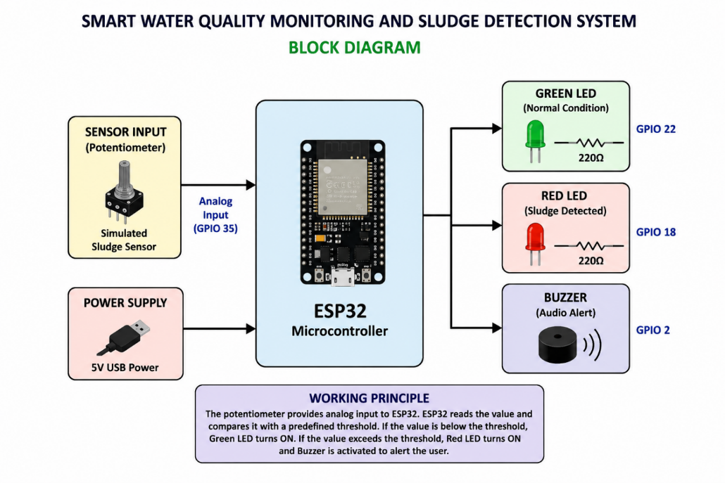

11. Circuit Diagram: 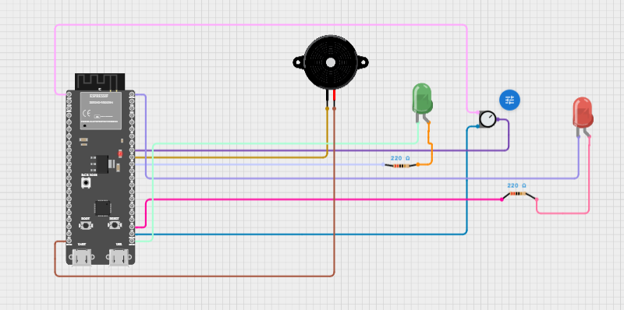
12. Required Components to Develop the Solution:
The proposed Smart Water Quality Monitoring and Sludge Detection System is developed using an ESP32 microcontroller, visual indicators, an audio alert unit, and supporting electronic components. The hardware and software components used in the project are listed below.
12.1 Hardware Components
S.No | Component | Quantity | Purpose
1 | ESP32 Development Board | 1 | Main processing unit
2 | Potentiometer (10kΩ) | 1 | Simulates sludge sensor readings
3 | Green LED | 1 | Indicates normal condition
4 | Red LED | 1 | Indicates sludge detected
5 | 220Ω Resistor | 2 | LED current limiting
6 | Active Buzzer | 1 | Audio alert generation
7 | PCB Board | 1 | Circuit implementation
8 | USB Cable | 1 | Programming and power supply
9 | Jumper Wires | As Required | Circuit connections

12.2 Software Components
S.No | Software | Purpose
1 | Arduino IDE | Program development and uploading
2 | EasyEDA | Schematic and PCB design
3 | ESP32 Board Package | ESP32 programming support
4 | Serial Monitor | Sensor value monitoring

12.3 Hardware Specifications
ESP32 Development Board
Parameter | Specification
Processor | Dual-Core Xtensa LX6
Clock Frequency | Up to 240 MHz
Operating Voltage | 3.3V
Flash Memory | 4 MB
Wi-Fi | 802.11 b/g/n
Bluetooth | BLE & Classic Bluetooth
ADC Resolution | 12-bit
GPIO Pins | Multiple Digital I/O Pins
Communication | UART, SPI, I2C, PWM
Potentiometer
Parameter | Specification
Resistance | 10kΩ
Type | Variable Resistor
Function | Simulated Analog Sensor
LEDs
Parameter | Specification
Type | Green LED / Red LED
Operating Voltage | 2V – 3.3V
Current Limiting Resistor | 220Ω
Buzzer
Parameter | Specification
Type | Active Buzzer
Operating Voltage | 3.3V – 5V
Function | Audio Alert

12.4 Development Tools
The following tools were used during project development:
• Arduino IDE for firmware development.
• EasyEDA for schematic design and PCB layout creation.
• ESP32 Board Manager package for ESP32 programming support.
• Serial Monitor for debugging and testing.
• Gerber File Generator for PCB manufacturing.

12.5 Specialized Equipment
The project does not require expensive laboratory equipment. Standard electronic development tools are sufficient.
Required tools include:
• Personal Computer or Laptop
• USB Programming Cable
• Soldering Kit (for hardware implementation)
• Multimeter (for testing)
• PCB Manufacturing Service
The selected components provide a low-cost, reliable, and scalable platform for developing the proposed sludge detection and alert system.
13. System Design and Working Principle
13.1 System Design
The Smart Water Quality Monitoring and Sludge Detection System is designed using an ESP32 microcontroller, a potentiometer acting as a sludge sensor, two LEDs for status indication, and a buzzer for audible alerts.
The ESP32 serves as the central processing unit of the system. It continuously reads analog values from the potentiometer through its Analog-to-Digital Converter (ADC). Based on the received sensor value, the ESP32 determines whether the monitored condition is normal or abnormal.
The system architecture consists of the following modules:
Input Module
The potentiometer acts as a simulated sludge sensor and generates analog voltage levels corresponding to sludge concentration.
Processing Module
The ESP32 processes the sensor readings and compares them with a predefined threshold value.
Output Module
The output section consists of:
• Green LED – Indicates normal operating conditions.
• Red LED – Indicates sludge accumulation above the threshold level.
• Buzzer – Generates an audible alert during abnormal conditions.

13.2 Working Principle
The system operates continuously by monitoring the sensor value obtained from the potentiometer.
Step 1: Sensor Data Acquisition
The potentiometer generates an analog voltage that represents the sludge level. This voltage is read by the ESP32 through GPIO 35.
Step 2: Data Processing
The ESP32 converts the analog voltage into a digital value using its internal ADC and compares the value with a predefined threshold.
Step 3: Decision Making
The controller evaluates whether the sensor value is below or above the threshold value.
Step 4: Normal Condition
When the sensor value is below the threshold:
• Green LED turns ON.
• Red LED remains OFF.
• Buzzer remains OFF.
This indicates that sludge levels are within acceptable limits.
Step 5: Alert Condition
When the sensor value exceeds the threshold:
• Green LED turns OFF.
• Red LED turns ON.
• Buzzer turns ON.
This indicates excessive sludge accumulation and alerts the user to take corrective action.

13.3 Algorithm
- Start the system.
- Initialize ESP32 GPIO pins.
- Read analog value from potentiometer.
- Compare sensor value with threshold.
- If sensor value exceeds threshold:
  - Turn ON Red LED.
  - Turn ON Buzzer.
  - Turn OFF Green LED.
- Else:
  - Turn ON Green LED.
  - Turn OFF Red LED.
  - Turn OFF Buzzer.
- Repeat continuously.

13.4 Advantages of the System
• Real-time monitoring.
• Automatic sludge detection.
• Instant visual and audio alerts.
• Low-cost implementation.
• Easy maintenance.
• Scalable for future IoT integration.
• Suitable for educational and industrial prototype applications.
The proposed design provides an efficient and reliable method for detecting abnormal sludge levels while reducing manual monitoring efforts and improving operational awareness.
14. Source Code Implementation:
#define GREEN_LED 22 // Green LED connected to GPIO22
#define RED_LED 18 // Red LED connected to GPIO18
#define BUZZER 23 // Buzzer connected to GPIO23
#define SENSOR_PIN 35 // Potentiometer output connected to GPIO35

// Threshold value for sludge detection
int threshold = 2000;

void setup() {
// Configure LEDs and buzzer as outputs
pinMode(GREEN_LED, OUTPUT);
pinMode(RED_LED, OUTPUT);
pinMode(BUZZER, OUTPUT);

// Start serial communication
Serial.begin(115200);

// Initially turn OFF all outputs
digitalWrite(GREEN_LED, LOW);
digitalWrite(RED_LED, LOW);
digitalWrite(BUZZER, LOW);
}

void loop() {

// Read analog value from the sensor
int sensorValue = analogRead(SENSOR_PIN);

// Display sensor value on Serial Monitor
Serial.print("Sensor Value: ");
Serial.println(sensorValue);

// Check if sludge level exceeds threshold
if (sensorValue > threshold) {

// Sludge detected condition
Serial.println("Sludge Detected!");

digitalWrite(RED_LED, HIGH); // Turn ON red LED
digitalWrite(GREEN_LED, LOW); // Turn OFF green LED
digitalWrite(BUZZER, HIGH); // Turn ON buzzer
}
else {

// Normal condition
Serial.println("Water Quality Good");

digitalWrite(RED_LED, LOW); // Turn OFF red LED
digitalWrite(GREEN_LED, HIGH); // Turn ON green LED
digitalWrite(BUZZER, LOW); // Turn OFF buzzer
}

// Small delay for stable readings
delay(500);
}
Code Explanation
Pin Definitions
The GPIO pins connected to the system components are defined at the beginning of the program.
- GPIO 35 → Potentiometer Input
- GPIO 22 → Green LED
- GPIO 18 → Red LED
- GPIO 23 → Buzzer
Setup Function
The setup() function executes only once during startup.
Functions performed:
• Configures LEDs and buzzer as output devices.
• Initializes serial communication at 115200 baud rate.
Loop Function
The loop() function executes continuously.
Functions performed:
• Reads sensor value from GPIO 35.
• Displays sensor readings on the Serial Monitor.
• Compares the sensor value with the threshold.
• Controls LEDs and buzzer according to system conditions.
Normal Condition
When sensor value is below threshold:
• Green LED ON
• Red LED OFF
• Buzzer OFF
Alert Condition
When sensor value exceeds threshold:
• Green LED OFF
• Red LED ON
• Buzzer ON
The implemented algorithm provides real-time monitoring and immediate alert generation, ensuring reliable sludge detection and system response.
15. Experimental Results and Output Analysis:
Case 1:
Senor value: 427
Light: Green light On
Water quality: Good
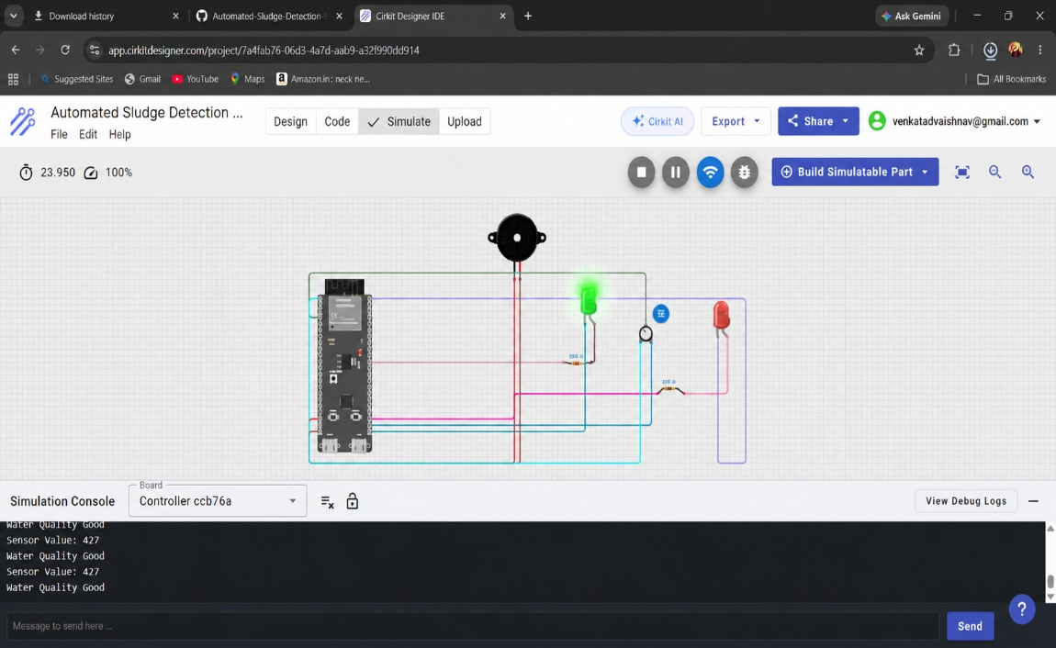
Case 2:
Senor value: 2616
Light: Red led one
Water quality: Tank cleaning required
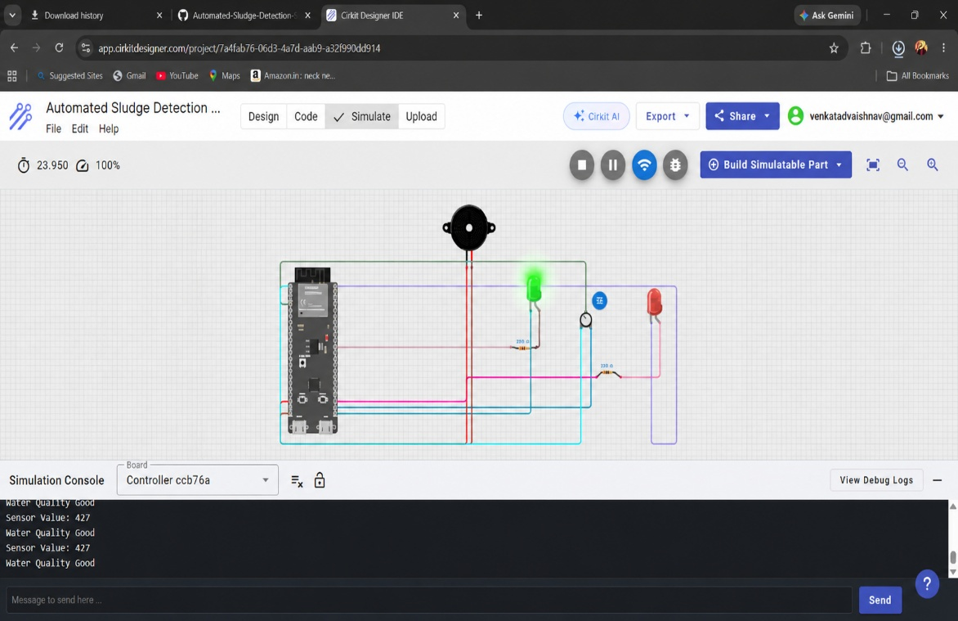

Discussion
The experimental results confirm that the proposed system can effectively monitor sludge levels and provide real-time alerts. The integration of ESP32, LEDs, buzzer, and sensor interface enables continuous monitoring while maintaining low cost and low power consumption. The system can be further enhanced by integrating IoT connectivity for remote monitoring and cloud-based data analysis.
Conclusion of Results
The developed prototype successfully achieved all project objectives. The system accurately detected threshold crossings, generated warning alerts, and demonstrated reliable performance suitable for smart water quality monitoring applications.
16. PCB Layout and Geber files:
The generated Gerber files have been uploaded to the GitHub repository and can be directly used for PCB fabrication.
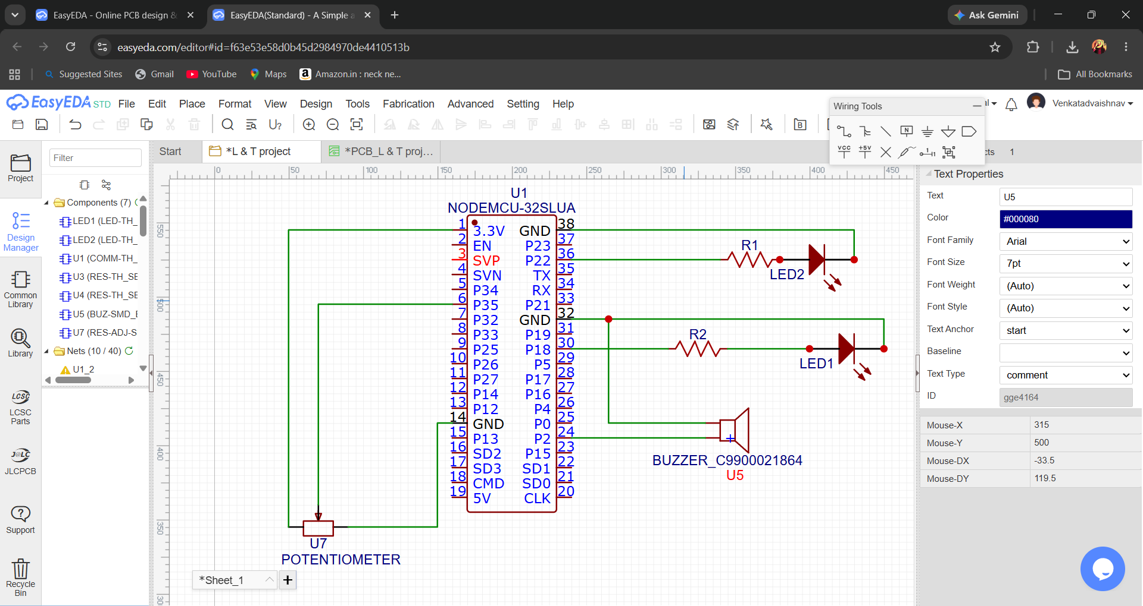
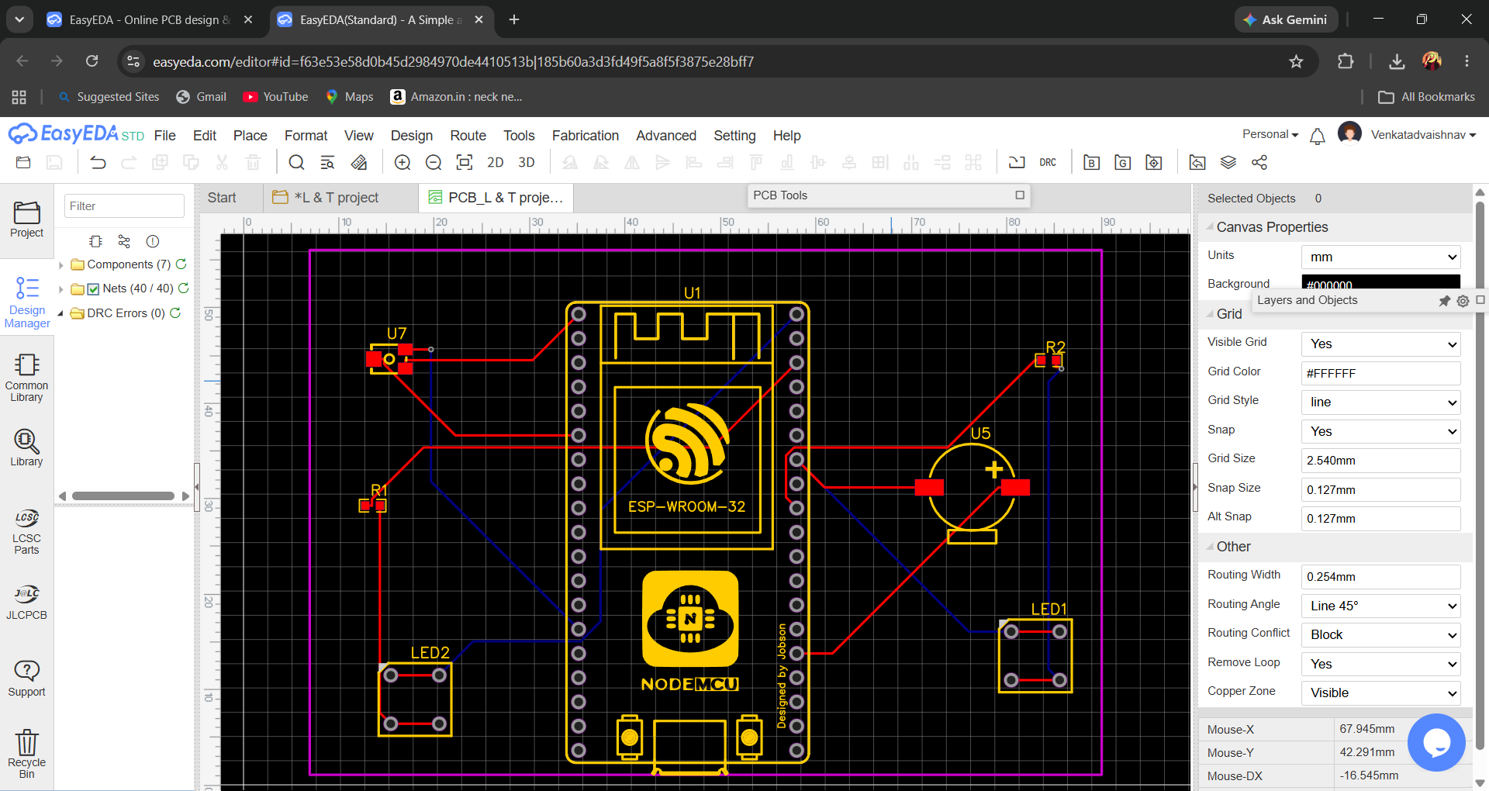
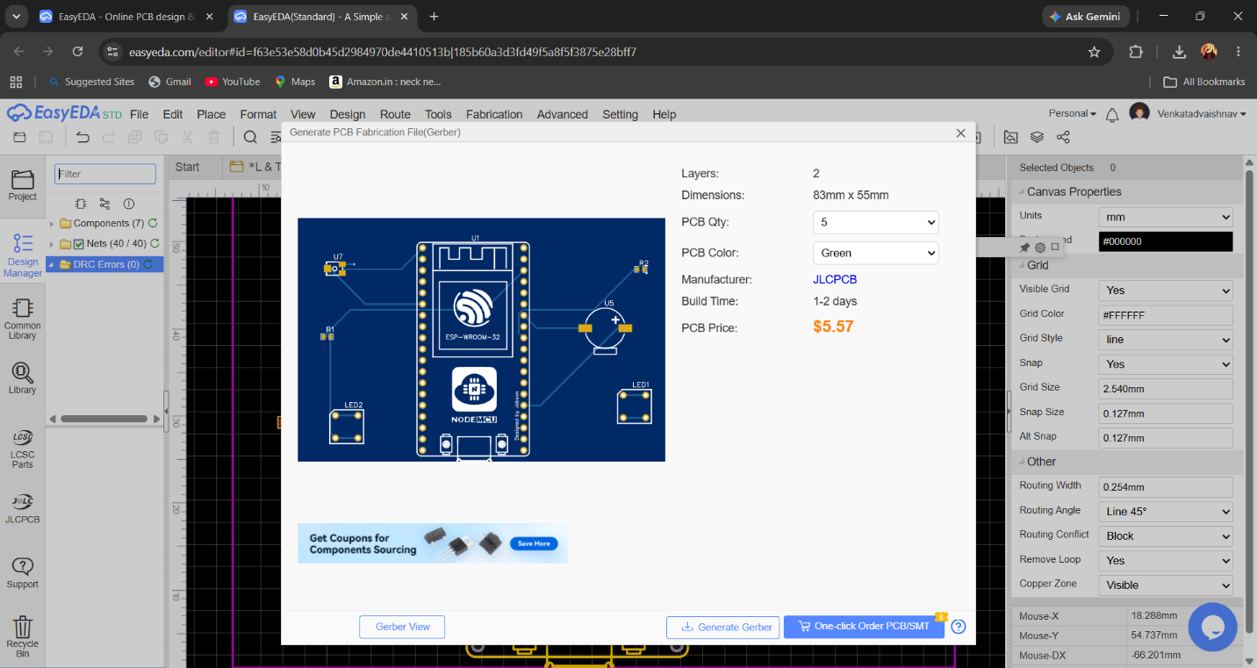
17. Video of the Demo:
A demonstration video of the working prototype has been uploaded separately to the GitHub repository. The video shows motion detection, LED activation, timeout operation, and overall system functionality.
18. Conclusion and Future Scope:
Conclusion
The Smart Water Quality Monitoring and Sludge Detection System was successfully designed and implemented using the ESP32 microcontroller. The system continuously monitors sludge levels through sensor inputs and provides real-time alerts using LEDs and a buzzer.
The developed prototype effectively distinguishes between normal and abnormal conditions. When sludge levels exceed the predefined threshold, the system generates both visual and audible warnings, enabling timely maintenance and preventing potential operational issues.
The project demonstrates the application of embedded systems in environmental monitoring and offers a cost-effective, reliable, and energy-efficient solution for water treatment and monitoring applications.
Achievements
- Successful integration of ESP32 with sensor, LEDs, and buzzer.
- Real-time sludge detection and monitoring.
- Immediate warning indication through alert mechanisms.
- Low-cost and compact system design.
- Stable and reliable operation.

Future Scope
The proposed system can be enhanced further by incorporating advanced technologies to improve functionality and scalability.
Future Enhancements
18.1 IoT-Based Remote Monitoring
The system can be connected to cloud platforms using Wi-Fi, allowing users to monitor water quality and sludge levels remotely through a web dashboard or mobile application.
18.2 Mobile Application Integration
A dedicated mobile application can be developed to provide real-time notifications and system status updates.
18.3 Data Logging and Analytics
Sensor readings can be stored in cloud databases for historical analysis, trend prediction, and maintenance planning.
18.4 Multiple Sensor Integration
Additional sensors such as:
- pH Sensor
- Turbidity Sensor
- Temperature Sensor
- Dissolved Oxygen Sensor
can be incorporated for comprehensive water quality assessment.
18.5 AI-Based Prediction
Machine learning algorithms can be applied to predict sludge accumulation patterns and optimize maintenance schedules.
18.6 Solar-Powered Operation
The system can be powered using solar energy for deployment in remote and off-grid locations.
18.7 Industrial-Scale Deployment
The prototype can be expanded into a full-scale monitoring solution for:
- Wastewater Treatment Plants
- Water Purification Systems
- Industrial Effluent Monitoring
- Smart City Water Management

Final Conclusion
The Smart Water Quality Monitoring and Sludge Detection System provides an efficient, low-cost, and scalable solution for monitoring sludge levels in water systems. The project successfully demonstrates the use of embedded systems and IoT-ready hardware for environmental monitoring applications and serves as a foundation for future smart water management systems.
19. References:
The following references were used during the design, development, and implementation of the Smart Water Quality Monitoring and Sludge Detection System.
- Espressif Systems, ESP32 Series Datasheet, Espressif Systems, Shanghai, China.
- Espressif Systems, ESP32 Technical Reference Manual, Espressif Systems.
- Arduino Documentation, Arduino IDE User Guide and Programming Reference, Arduino Official Documentation.
- EasyEDA Documentation, PCB Design and Gerber File Generation Guide, EasyEDA Official Documentation.
- Simon Monk, Programming Arduino: Getting Started with Sketches, McGraw-Hill Education.
- Michael Margolis, Arduino Cookbook, O'Reilly Media.
- National Institute of Standards and Technology (NIST), Environmental Monitoring and Smart Water Management Systems, Technical Publications.
- World Health Organization (WHO), Water Quality Monitoring Guidelines, WHO Publications.
- United States Environmental Protection Agency (EPA), Wastewater and Sludge Management Guidelines, EPA Technical Reports.
- IEEE Research Publications on:
- Smart Water Monitoring Systems
- IoT-Based Environmental Monitoring
- Embedded Systems for Water Quality Assessment
- GitHub Documentation, Version Control and Project Repository Management, GitHub Official Documentation.
- ESP32 Arduino Core Documentation, ESP32 Programming Framework, Espressif Systems.
- PCB Manufacturing Guidelines, Gerber File Standards and PCB Fabrication Process, Industry Documentation.
- Embedded Systems Design References, Microcontroller-Based Monitoring and Automation Systems, Academic Publications.
- Water Treatment Engineering References, Sludge Monitoring and Wastewater Management Techniques, Environmental Engineering Literature.

GitHub Repository Contents
The GitHub repository for this project contains:
• Project Report
• Source Code
• Circuit Diagram
• PCB Layout
• 3D PCB Design
• Gerber Files
• Hardware Images
• Demonstration Video

Project Summary
Project Title: Smart Water Quality Monitoring and Sludge Detection System Using ESP32
Microcontroller: ESP32 Development Board
Development Tools:
- Arduino IDE
- EasyEDA
- GitHub
Key Features:
- Real-Time Monitoring
- Sludge Detection
- Visual Alerts
- Audio Alerts
- Low-Cost Design
- PCB Implementation
- Gerber File Generation
Project Status: Successfully Completed

